

**University name: Muhammad Nawaz Sharif University of Agriculture, Multan**

**Student name: Zain Javed**

**Student roll no: 2023-uam-1903**

**Department name: Computer Science**

**Subject name: Data Structure**

**Subject tutor name: Sir Nasir Siddiqui**

**Project name: Railway Reservation System**

**Problem:**

The system likely aims to simplify railway reservation tasks such as booking, canceling tickets, managing trains, and keeping track of passengers. The program might provide structured operations for handling reservations.

**Objectives:**

* **Booking tickets**: Assign seats and store passenger details.
* **Cancellation**: Allow users to cancel a ticket and update availability.
* **Train Management**: Add or modify train schedules and details.
* **Display Information**: Show available trains, booked tickets, etc

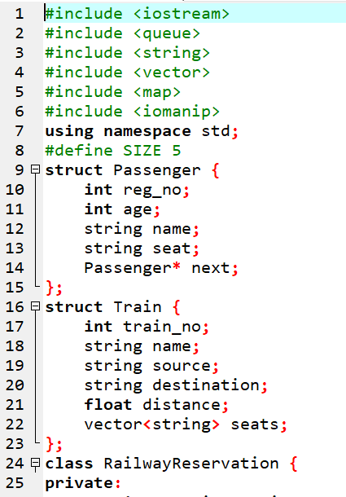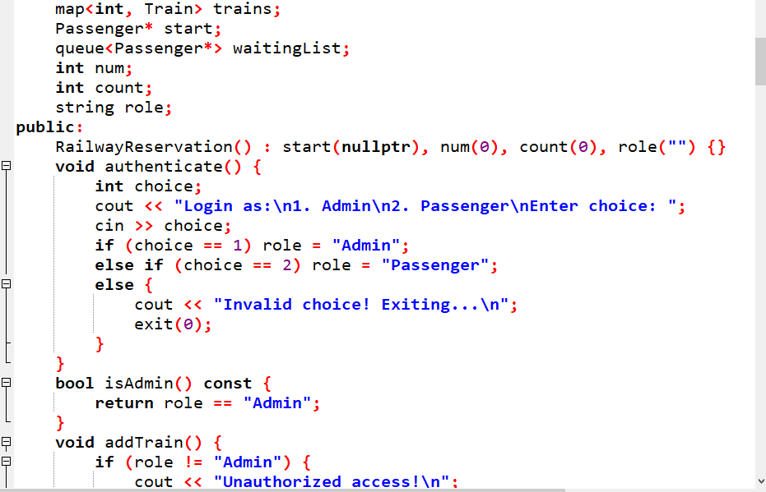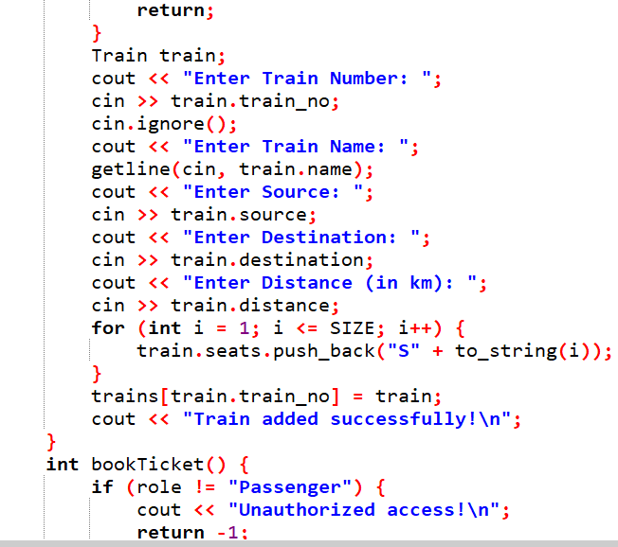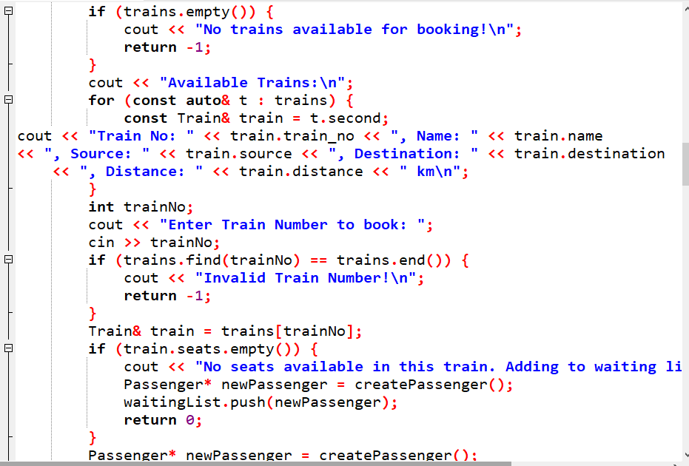

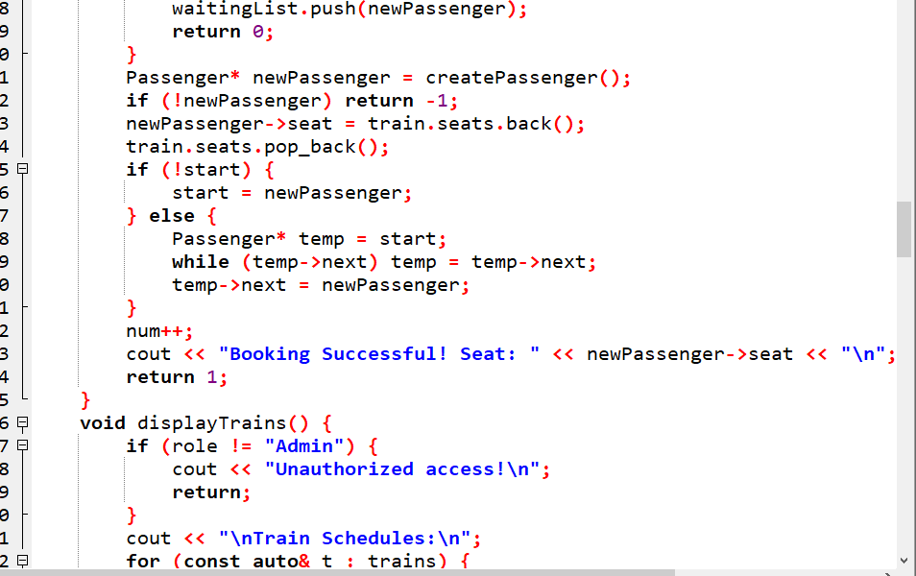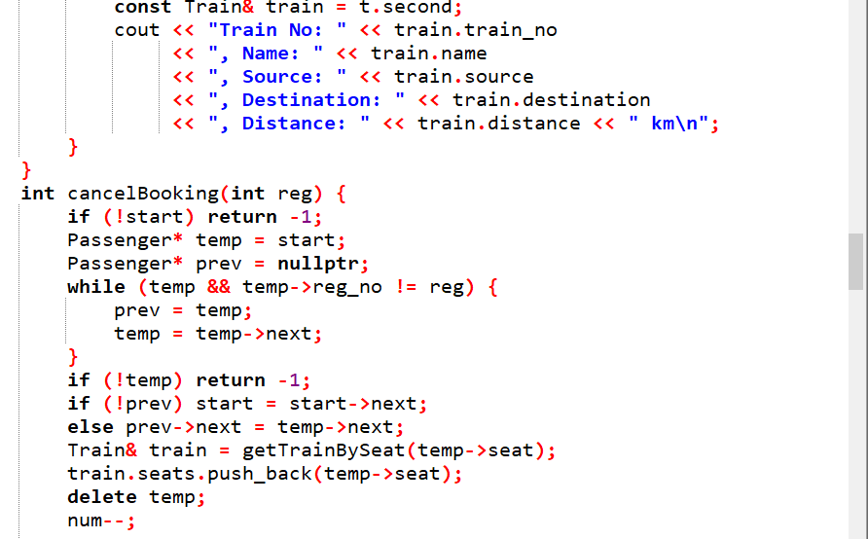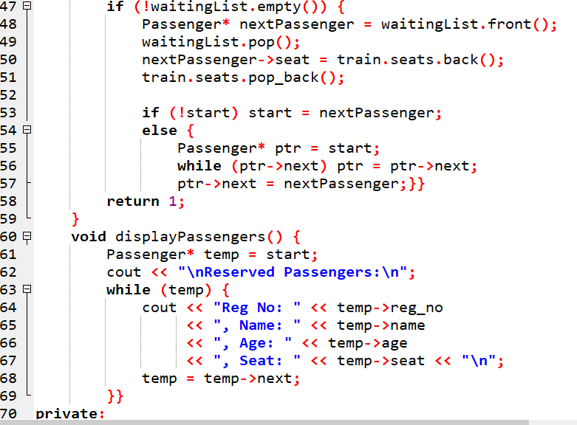

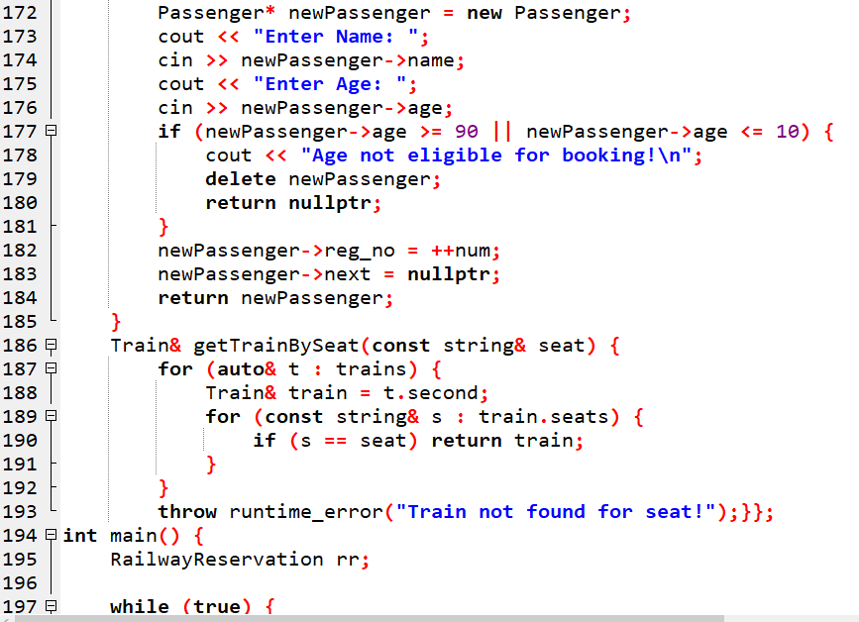

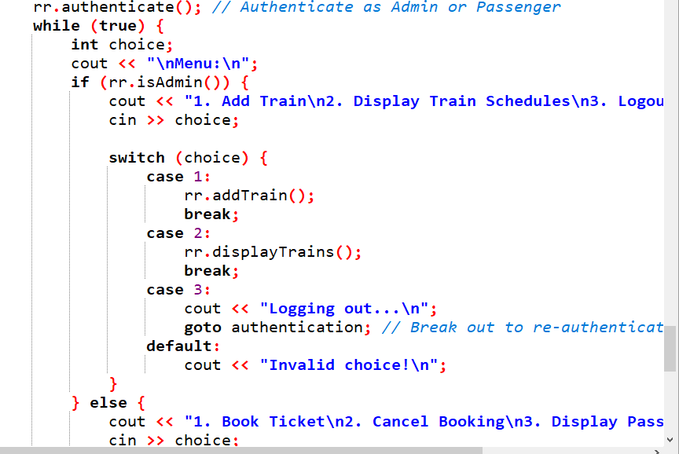

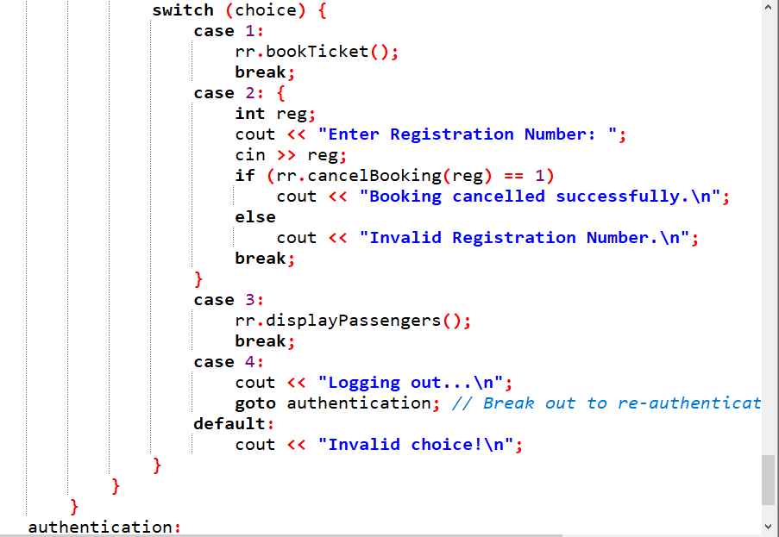

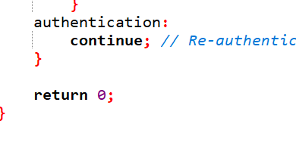

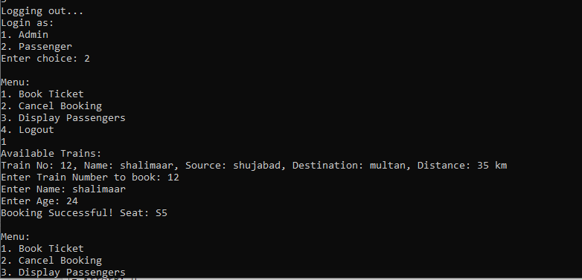

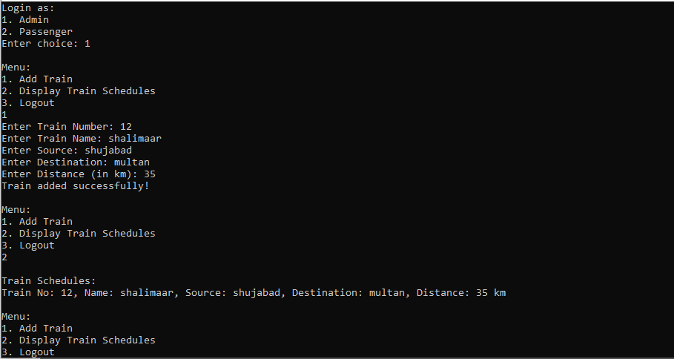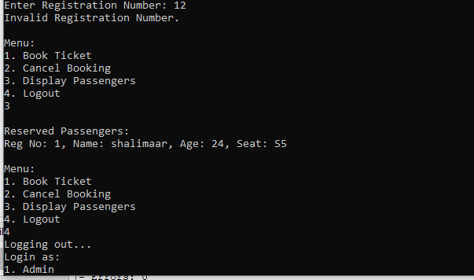

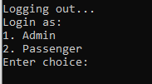

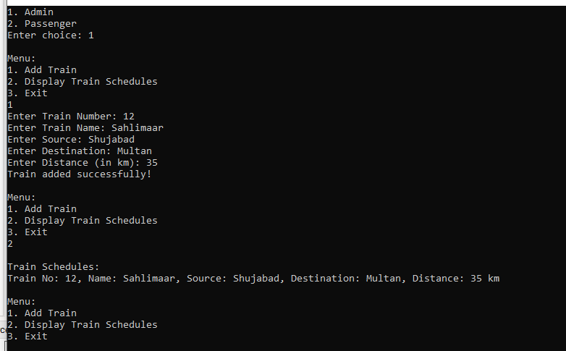

**Data Structures Used:**

* **Passenger**: Stores individual passenger details (e.g., registration number, age, seat).
* **Train:** Manages train details, such as number, source, destination, and available seats.
* **Vector** : Used for lists like seats.
* **Map:** Likely for fast access or pairing train details.
* **Queue:** For processing passenger requests or similar features.
* **Pointer: The Passenger** next indicates linked list implementation for passenger management.

**Completed Objective:**

* **Train management**: Adding trains (addTrain).
* **Display functionality:** Trains and passengers (displayTrains, displayPassengers).
* **Ticket booking:** bookTicket.
* **Ticket cancellation:** cancelBooking.